2017
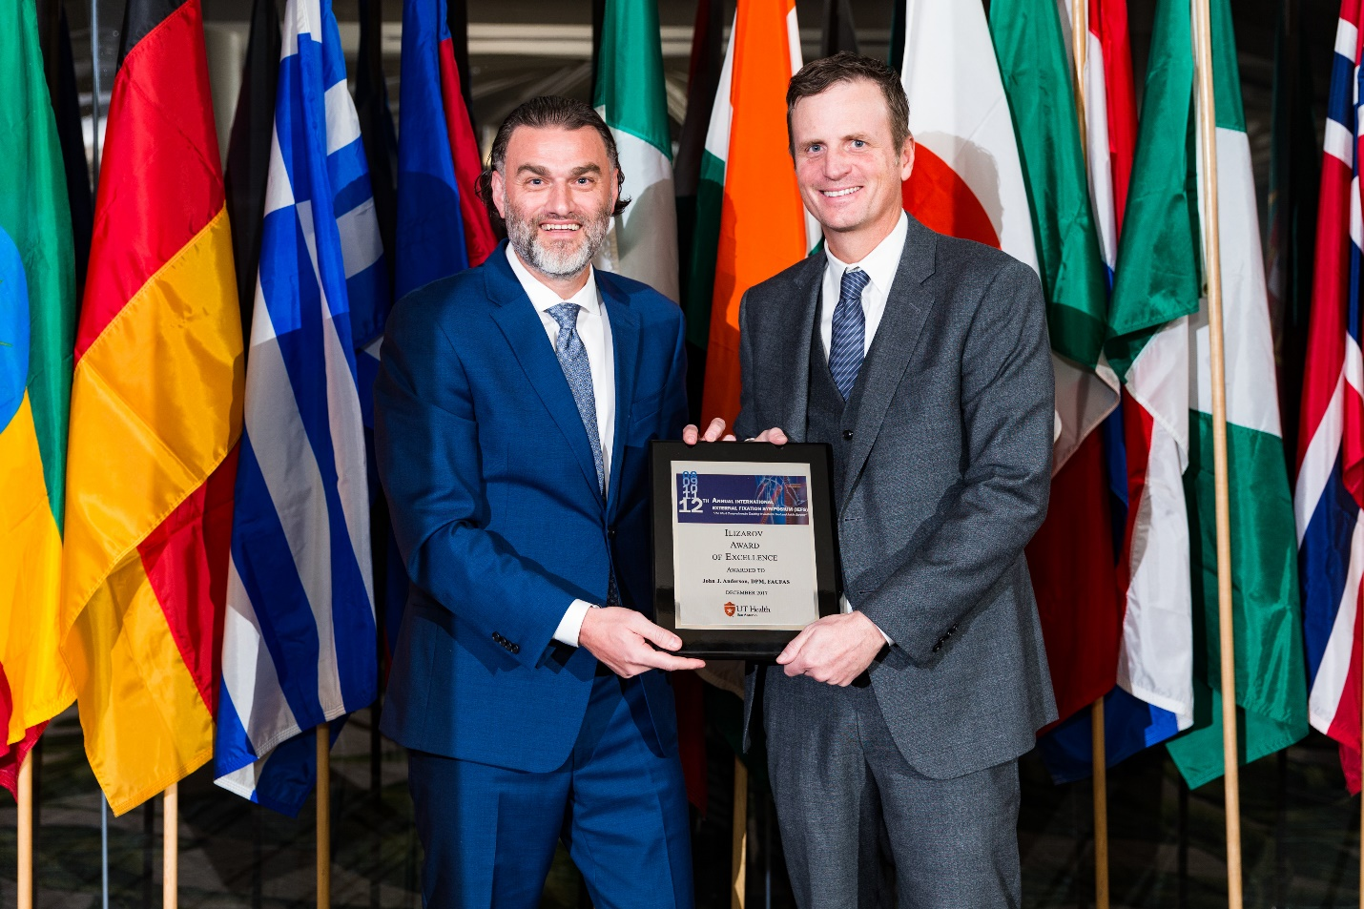
Thomas Zgonis, DPM, FACFAS, presents John J. Anderson, DPM, FACFAS, with the Ilizarov Award of Excellence at the 12th Annual International External Fixation Symposium 2017.

