Ilizarov Award of Excellence
Patrick R. Burns, DPM, FACFAS

December 2013

Patrick R. Burns, DPM, FACFAS was awarded the Ilizarov Award of Excellence at the 8th Annual International External Fixation Symposium (IEFS) sponsored by the University of Texas Health Science Center on December 13, 2013 in San Antonio, Texas. Dr. Burns practices in Pittsburgh, PA and is an Assistant Professor of Orthopedic Surgery and the Podiatric Surgical Residency Program Director, Foot and Ankle Division, University of Pittsburgh School of Medicine. His many years of service with expertise in external fixation and diabetic foot reconstruction to the Pittsburgh community, active research participation, numerous publications and book chapters, resident education and training at the University of Pittsburgh School of Medicine have distinguished him as honorary recipient of this year’s award.

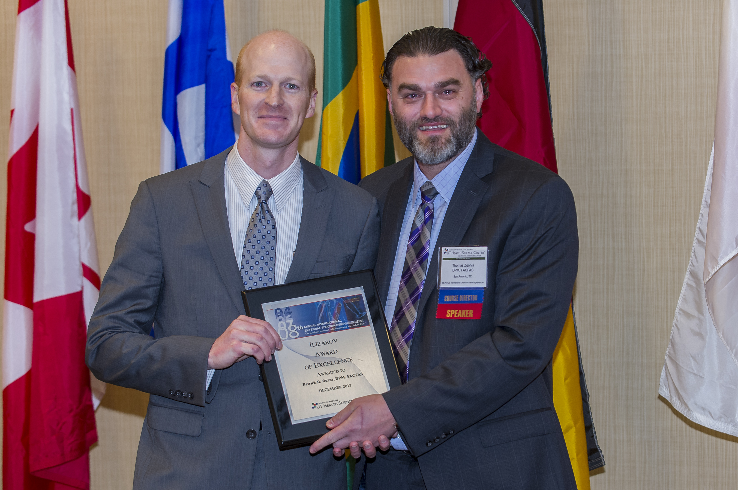

Thomas Zgonis, DPM, FACFAS, presents
Patrick R. Burns, DPM, FACFAS, with the
Ilizarov Award of Excellence at the 8th Annual International External Fixation Symposium 2013.
Of Excellence at the 4th Annual International External Fixation Symposium2008.

