Ilizarov Award of Excellence

**Armin Koller, MD**

December 2009

Dr. Koller is currently the Chief, Division of Technical Orthopaedics, and Co-Chief, Interdisciplinary Diabetic Foot Center at Mathias Hospital, Rheine, Germany. He received his medical degree in 1991 from the Westfaelische Wilhelms-University, Muenster, Germany, and became Board Certified in Orthopaedic Surgery in 1998. He is an active member of the German Orthopaedic Society, German Foot and Ankle Association, German Association for Foot Surgery, German Diabetological Society, and International Society for Prosthetics and Orthotics. He serves on the Editorial Board for *Clinics in Podiatric Medicine and Surgery* and for *Fuss und Sprunggelenk*, the German Journal of Foot and Ankle Surgery.

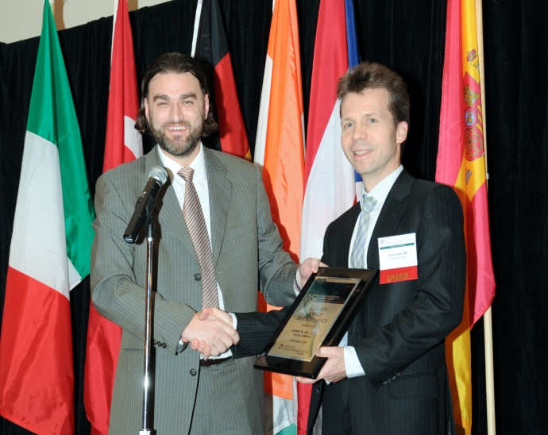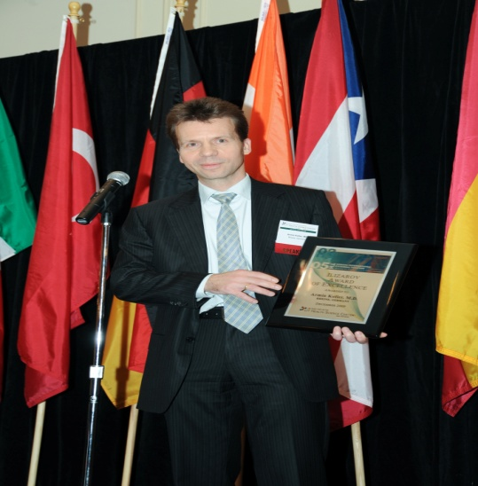

*Armin Koller, M.D., with the*

*Ilizarov Award Of Excellence.*

*Thomas Zgonis, DPM, FACFAS, presents*

*Armin Koller, M.D., with the Ilizarov Award of Excellence at the 5th Annual International External Fixation Symposium 2009.*

*Of Excellence at the 4th Annual International External Fixation Symposium2008.*

