Ilizarov Award of Excellence
Thomas S. Roukis, DPM, PhD, FACFAS

December 2011

Thomas S. Roukis, DPM, PhD, FACFAS was awarded the Ilizarov Award of Excellence at the 7th Annual International External Fixation Symposium (IEFS) sponsored by the University of Texas Health Science Center on December 9, 2011 in San Antonio, Texas. Dr. Roukis is an Attending Podiatric Surgeon within the Department of Orthopedics, Podiatry, and Sports Medicine at the Gundersen Lutheran Medical Center in La Crosse, Wisconsin, USA. He is the upcoming Secretary-Treasurer for the American College of Foot and Ankle Surgeons and holds Adjunct Clinical Professor Faculty positions at multiple Colleges or Universities of Podiatric Medicine throughout the country. Dr. Roukis has completed an AO International Trauma Fellowship in Mainz, Germany, an American College of Foot and Ankle Surgeons Division 14 European Foot and Ankle Surgery Fellowship, and a Reconstructive Foot and Ankle Research and Surgery Fellowship in Des Plaines, Illinois

Dr. Roukis serves as a peer reviewer as well as being on the editorial board of numerous scientific publications and is an active member in professional associations. He has received multiple awards and scholarships related to research and clinical expertise in complex foot and ankle surgery and has served as principal or co-investigator on 19 clinical trials and scientific studies. He has published over 140 peer-reviewed scientific articles and has given more than 265 oral and poster presentations nationally and internationally. His expertise in external fixation, diabetic foot reconstruction and clinical research has distinguished him as the honorary recipient of this year’s award.

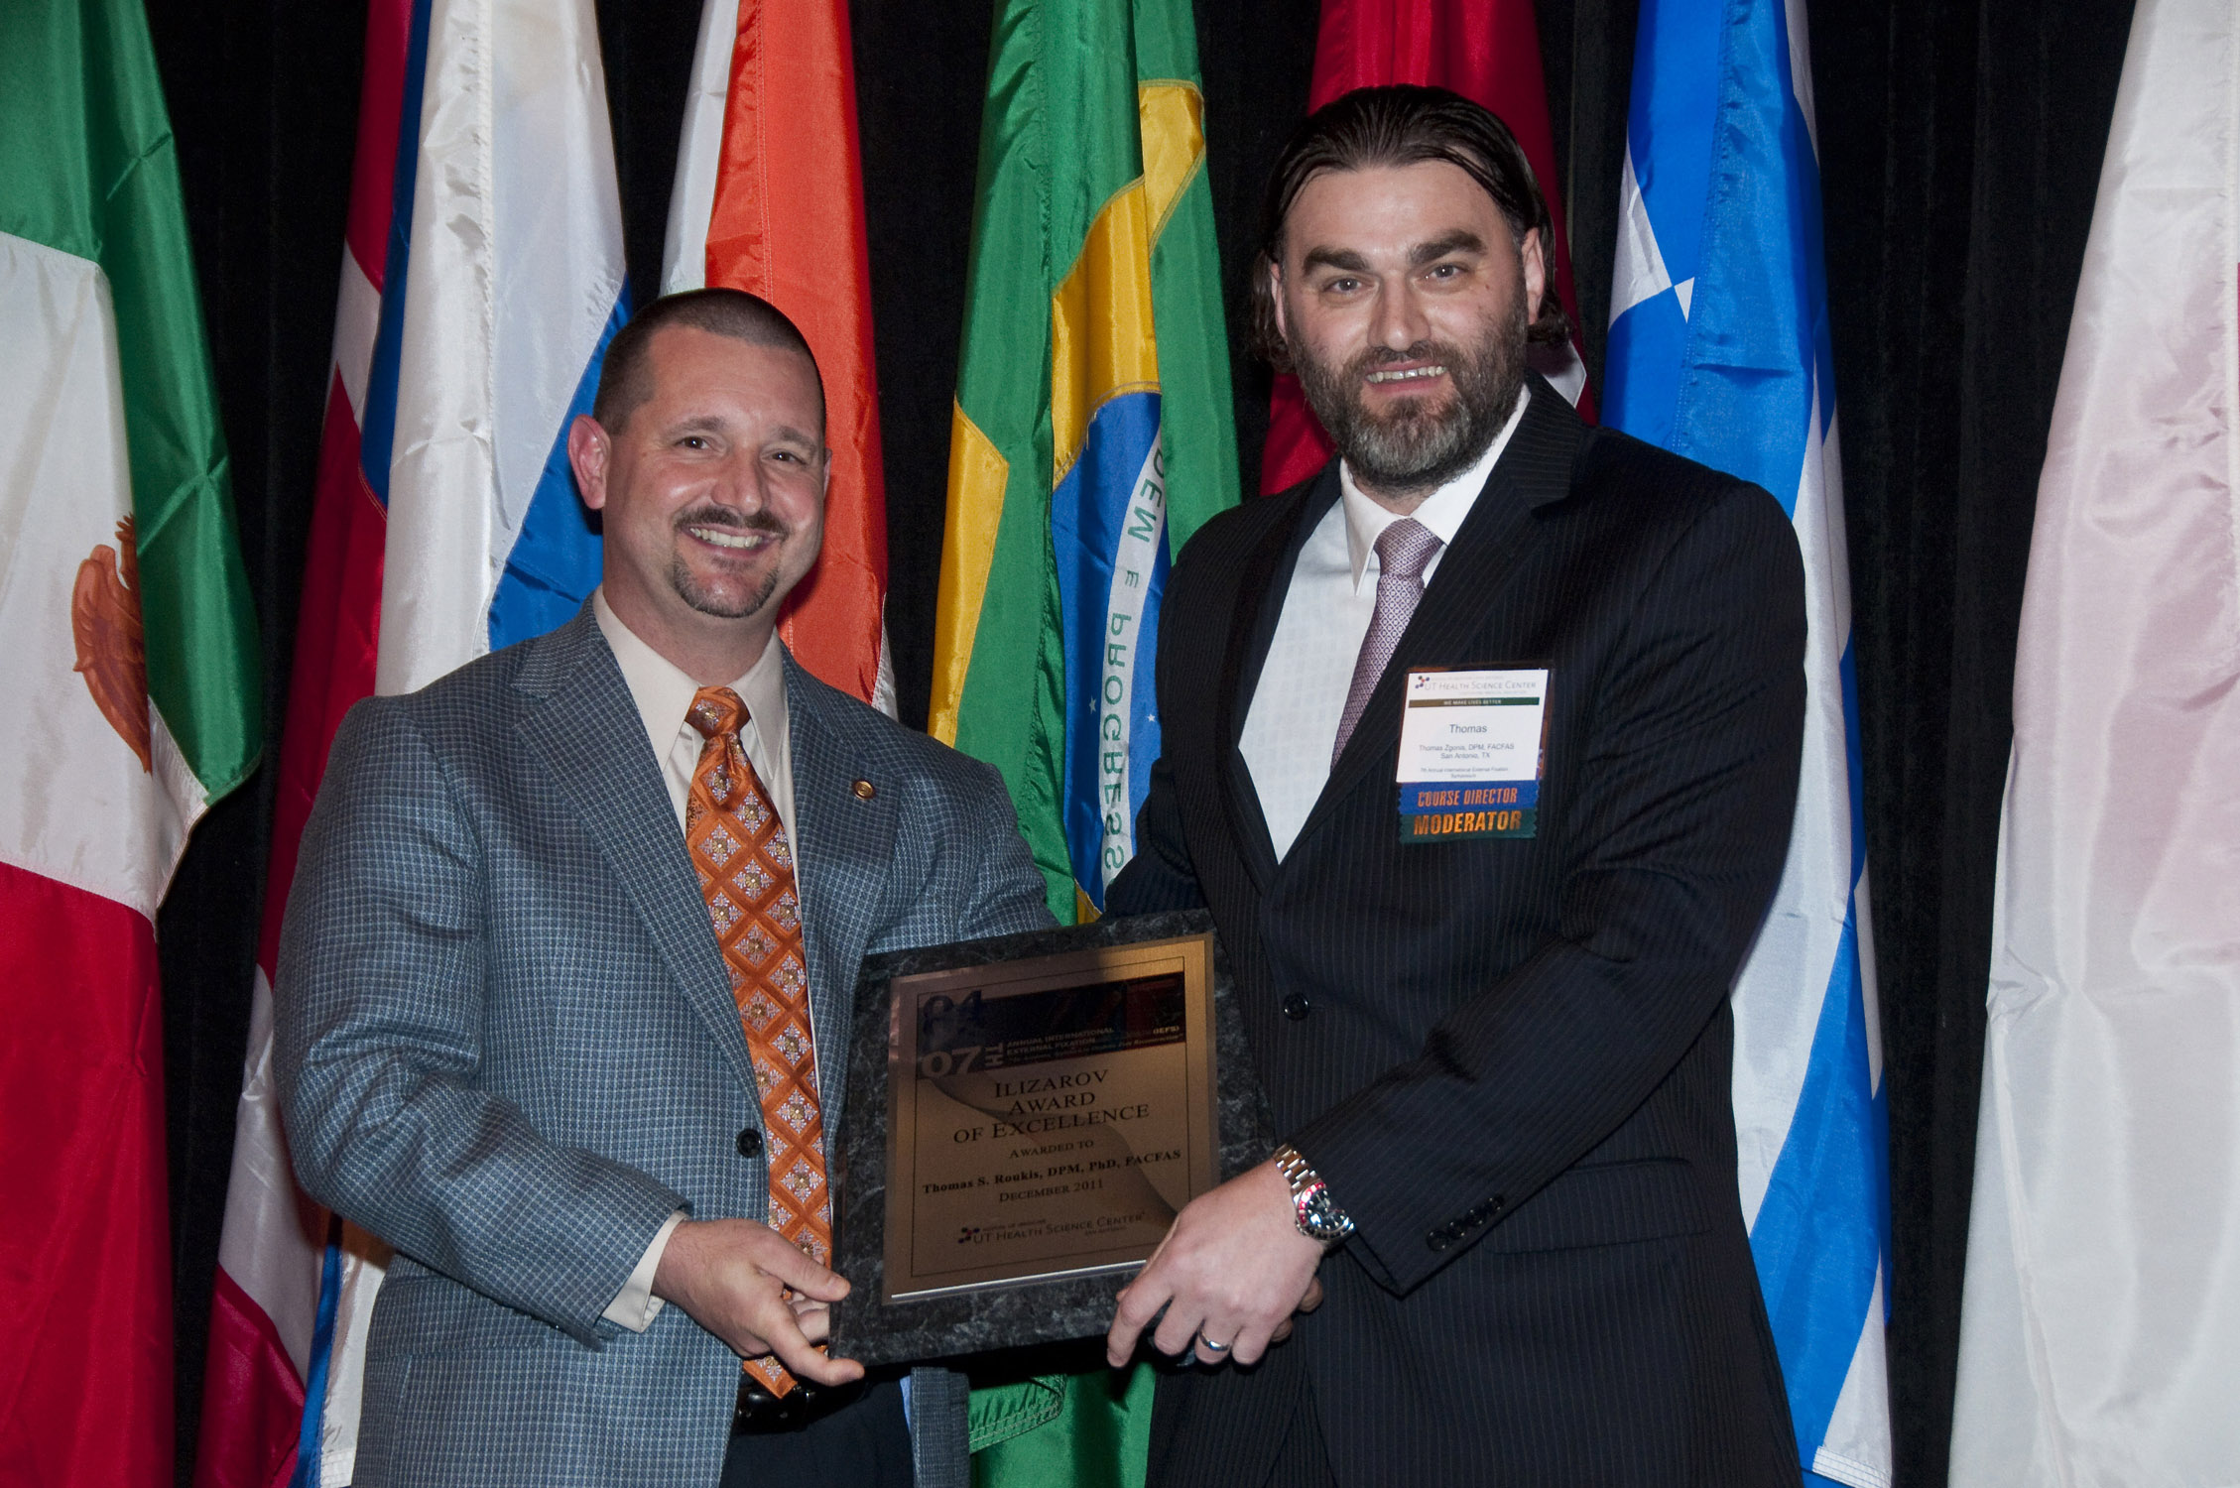
Thomas Zgonis, DPM, FACFAS, presents
Thomas S. Roukis, DPM, PhD, FACFAS, with the Ilizarov Award of Excellence at the 7th Annual International External Fixation Symposium 2011.
Of Excellence at the 4th Annual International External Fixation Symposium2008.

