Ilizarov Award of Excellence
John J. Stapleton, DPM, FACFAS

December 2016

John J. Stapleton, DPM, FACFAS, was awarded the Ilizarov Award of Excellence at the 11th Annual International External Fixation Symposium (IEFS) sponsored by UT Health San Antonio in collaboration with the University of Pittsburgh Medical Center on December 10, 2016, in San Antonio, Texas. Dr. Stapleton practices in Allentown, Pennsylvania, at VSAS Orthopedics and he serves as Clinical Assistant Professor of Surgery at Penn State College of Medicine in Hershey, Pennsylvania. His many years of service with surgical expertise in traumatic and diabetic limb salvage with external fixation, teaching, numerous publications and book chapters, have distinguished him as the honorary recipient of this year’s award.

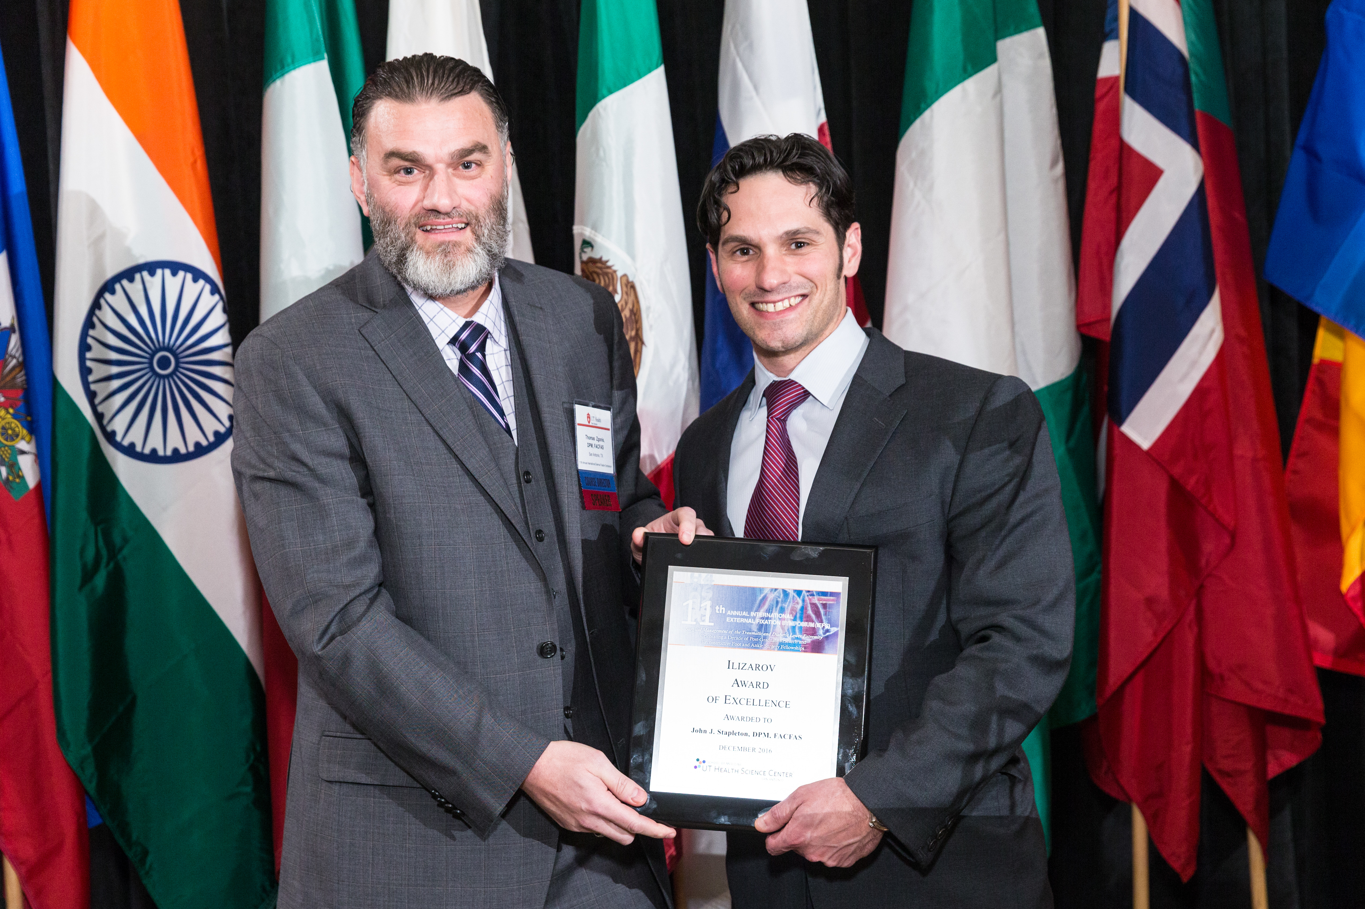

Thomas Zgonis, DPM, FACFAS, presents
John J. Stapleton, DPM, FACFAS, with the
Ilizarov Award of Excellence at the 11th Annual International External Fixation Symposium 2016.
Of Excellence at the 4th Annual International External Fixation Symposium2008.

